***Task artificial intelligence***(AI):

ROS on linux step :

Step by step :

1. Installation program parallel Desktop in mac M1

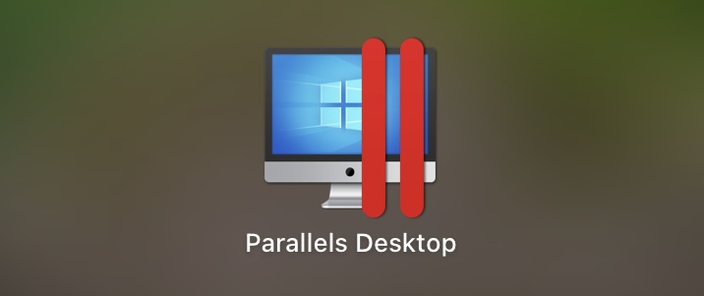

1. Install Ubuntu 20.04

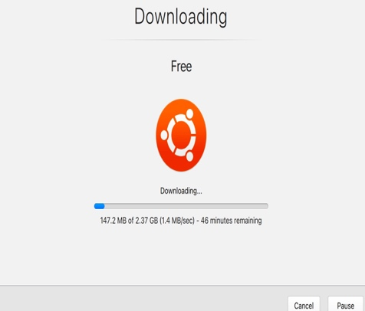

1. Sign in ubuntu
2. Orders in ROS
3. Install ROS

